David Lakes

MATH 200

Project 1

Professor Brown

Due November 12, 2024

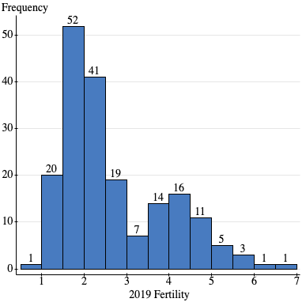

Fertility rate skews right.

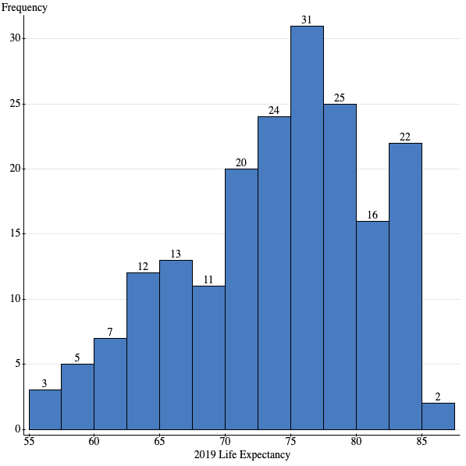

Life expectancy skews left.

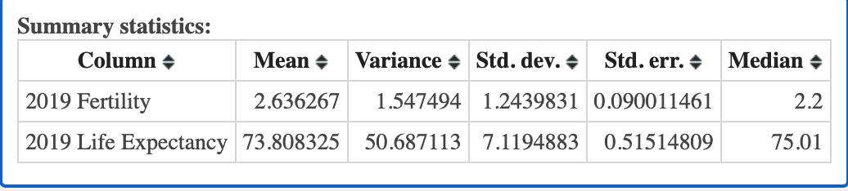

In 2019 the average global fertility rates and life expectancy were 2.64 and 73.81, respectively. The variance in fertility rates and life expectancy were 1.54 and 50.69 with a standard deviation of 1.23 and 7.12, respectively. This points to a fairly satisfied life expectancy considering the wide variance. The standard deviation suggests that most of the world fits within a 14 year gap of the average life expectancy.

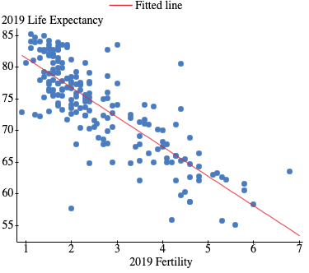

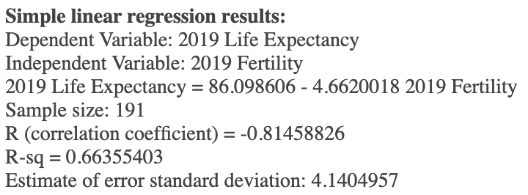

The correlation coefficient of -0.81 demonstrates a strong negative linear correlation between fertility rate and life expectancy. That is to say, the higher the birthrate, the lower the life expectancy is on average. We can somewhat predict life expectancy with the formula Life Expectancy = 86.098606 - 4.6620018 x Fertility. The R2 = .6636, meaning that the 66.36% of the variance in life expectancy can be attributed to the fertility rate. This leaves room for other variables like access to healthcare to influence the variance in life expectancy.

The fertility and life expectancy of the United States is 1.7 and 79.11, respectively. Given the regression line, we would expect the US to have a life expectancy of 78.18. We calculate this with 86.098606 - 4.6620018 x US Fertility. Given the actual fertility rate of the US, the US has a longer life expectancy than predicted.

Some other countries that have the same fertility, and therefore the same predicted life expectancy are the UK, Sweden, New Zealand, Ireland, Costa Rica, China, and Brazil. Their actual life expectancy rates are as follows:

UK: 81.77

Sweden: 83.33

New Zealand: 82.8

Ireland: 82.81

Costa Rica: 80.94

China: 77.47

Brazil: 75.57

Countries within ± 0.2 points of the US’s fertility rate are Austria, Brunei, Colombia, France, Russia, and Trinidad and Tobago. Their actual and predicted life expectancies are as follows, respectively:  
Austria: 82.05, 79.106

Brunei: 76.35, 77.71

Colombia: 77.87, 77.71

France: 83.13, 79.57

Russia: 72.99, 79.11

Trinidad and Tabago: 73.91, 78.18

The Nordic countries, which often have the highest standard of living in the world, are as follow (actual and predicted life expectancies, respectively):

Denmark: 81.4, 78.18

Finland: 82.48, 79.58

Iceland: 83.52, 77.71

Norway: 82.94, 79.11

Sweden: 83.33, 78.18

For these countries, fertility rates are between 1.4-1.8.

There are numerous factors that can affect life expectancy and fertility rate like access to healthcare to quality healthcare, access to sexual education, poverty, access to contraceptives, views on gender roles, attitudes towards feminism and women, political conflict, access to clean water and nutritious food, and violence. To elaborate, in the Nordic countries where every citizen has the right to quality healthcare, education, and positive views towards feminism, each country’s life expectancy exceeds their predicted life expectancy.

However, countries with similar fertility rates to the US like Russia, Brazil, and Trinidad and Tabago have actual life expectancy rates well below their predicted life expectancy rate.

These examples demonstrate that correlation can’t be seen as causation. While there is a negative relationship between fertility rate and life expectancy, we can see examples of countries with similar fertility rates being well above and well below their predicted life expectancies. This is due to a variety of confounding variables that actually affect life expectancy.

This regression model cannot be used to predict the life expectancy of one particular person due confounding variables. This regression model is only at best, an educated guess for predicting average life expectancy and is only somewhat accurate. This regression model is too broad for individuals. To more accurately predict the life expectancy of a person, you would need to take in their environmental and genetic make-up into account.

Gapminder

Looking at data from 20, 40, and 60 years ago, we can see that generally, the further in the past we go, the shorter the life expectancy is and the higher the fertility rate is. This could be due to a number of reasons, such as advances in healthcare and changes in gender roles.

While there is still great stratification in the world when it comes to fertility and life expectancy rates, the data becomes more stratified as we go back in time. This could be attributed to advances in technology, medicine, access to information, NGOs becoming more efficient, and changes in gender roles.

Ted Talk

Hans Rosling’s TED Talk takes a closer look at the data from the project by breaking down the statistics for different countries. He points to how different factors like investing in healthcare is typically needed to generate more wealth per capita. He also demonstrates how drastically outcomes can change over time.

What I think that I appreciated most from his TED Talk was how preconceived notions can distort one’s view on reality. Even as I wrote this paper, I speculated and made educated guesses on how different variables might be in effect. However, to fully understand the situation of a country or individual, there needs to be a great amount of context to get an accurate image.